**PROJECT: DOCS**

**NAME: K SAI SMARAN**

**REGISTRATION NUMBER: 16MIS0303**

**UNIT TESTING:**

**Signup Page:**

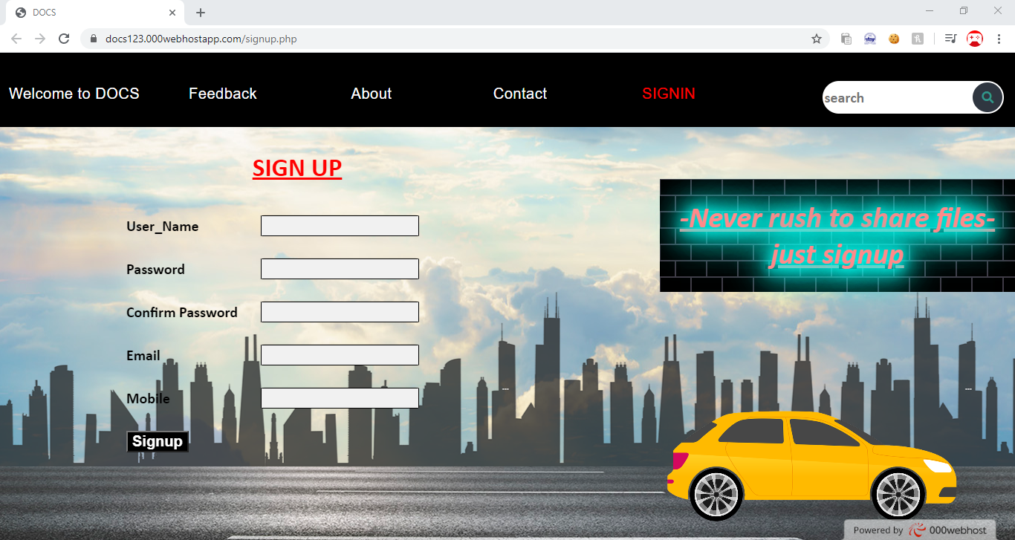

**Error if we miss a field:**

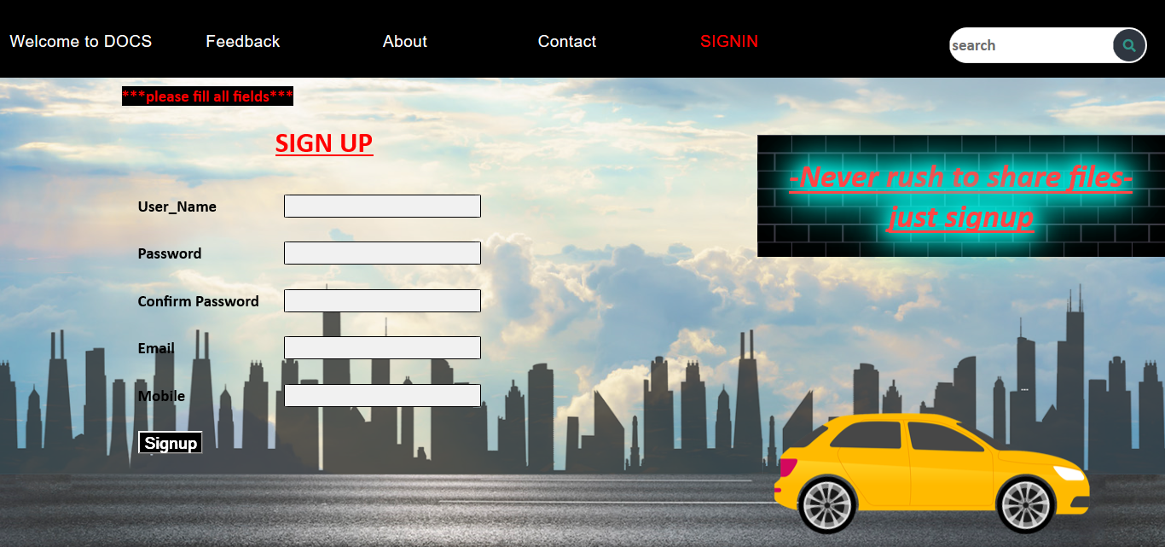

**Error if mobile number is not 10digit:**

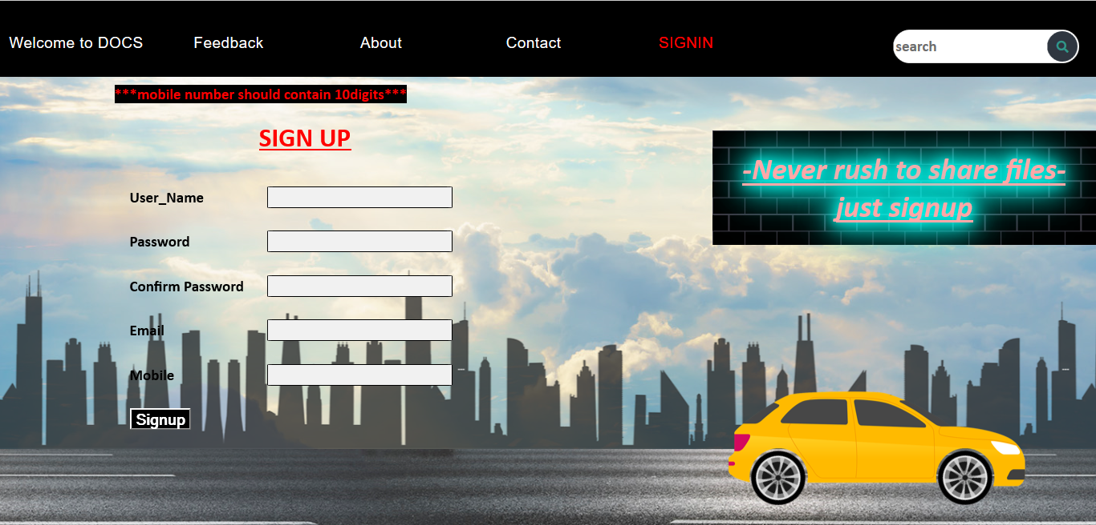

**Error if password fields does not match:**

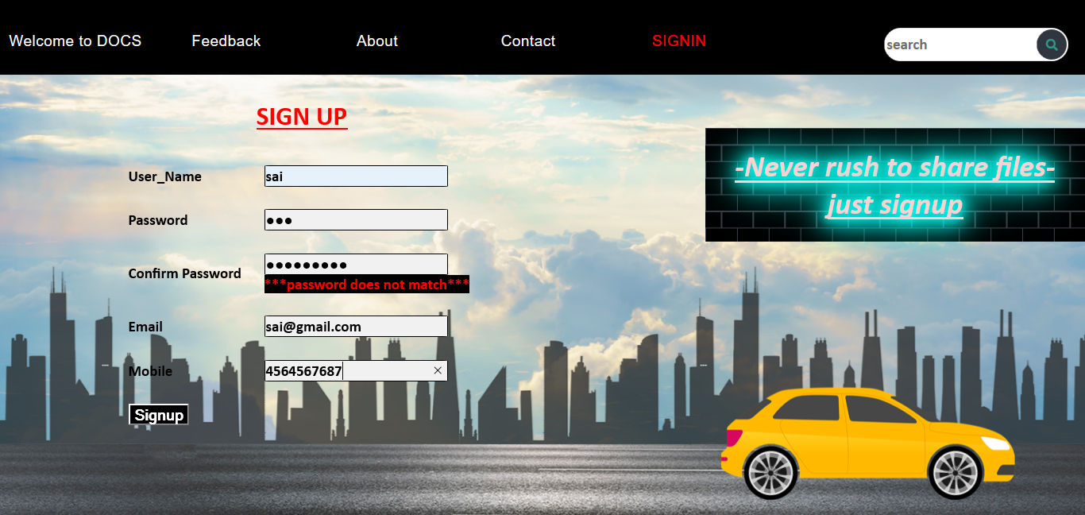

**FEEDBACK FORM:**

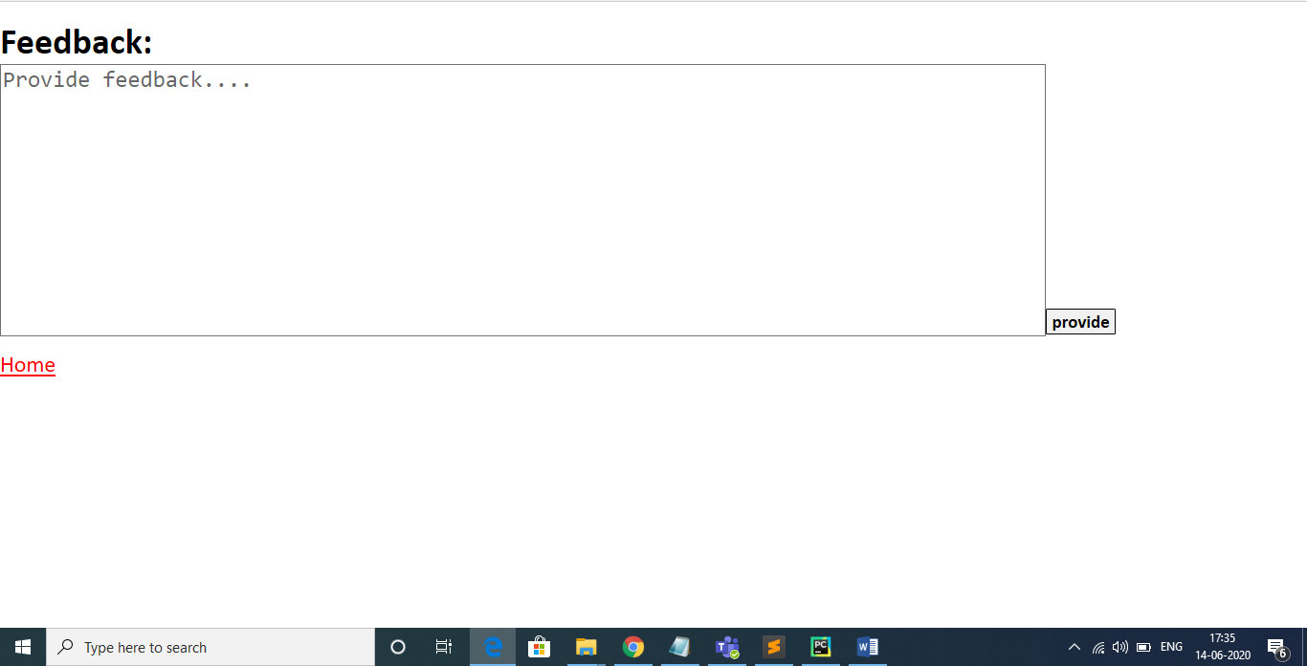

**ABOUT section:**

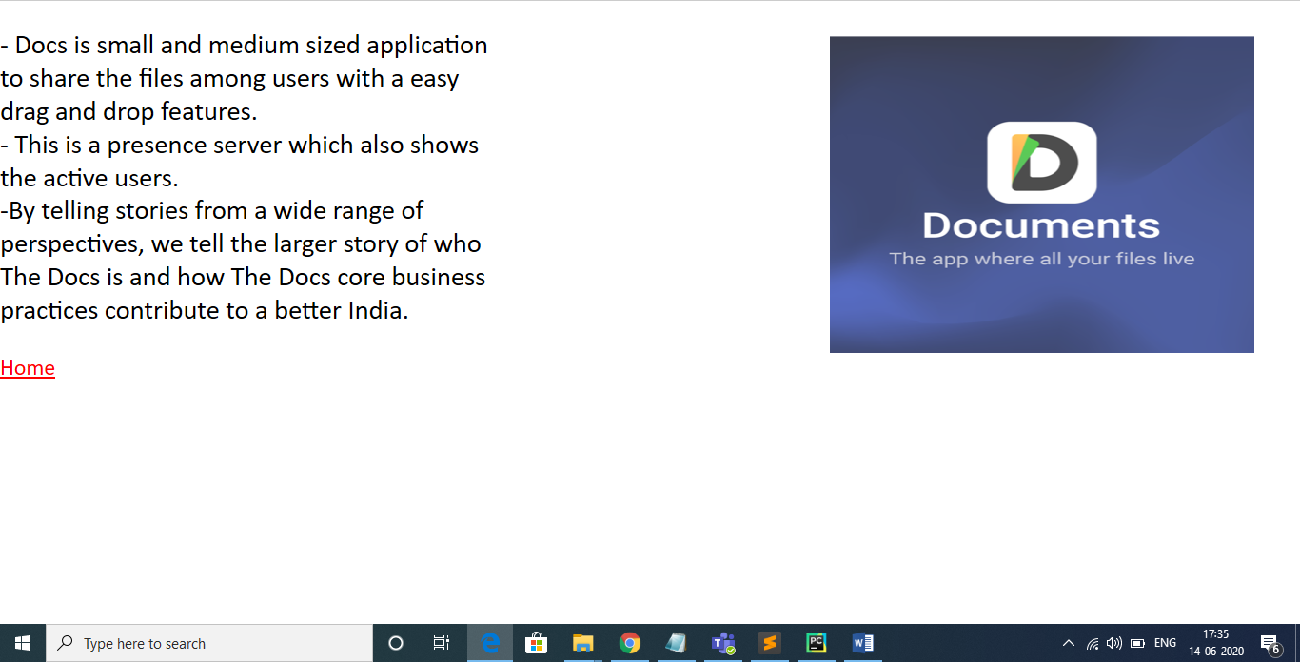

**Contact Info:**

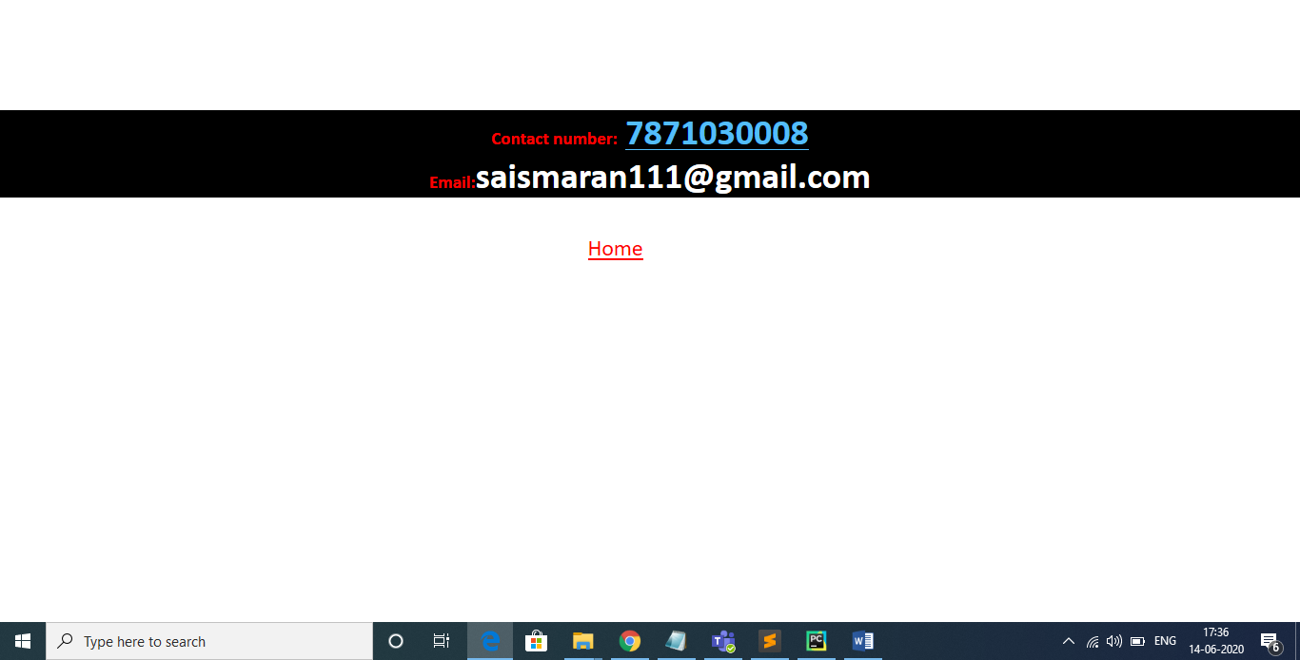

**LOGIN PAGE:**

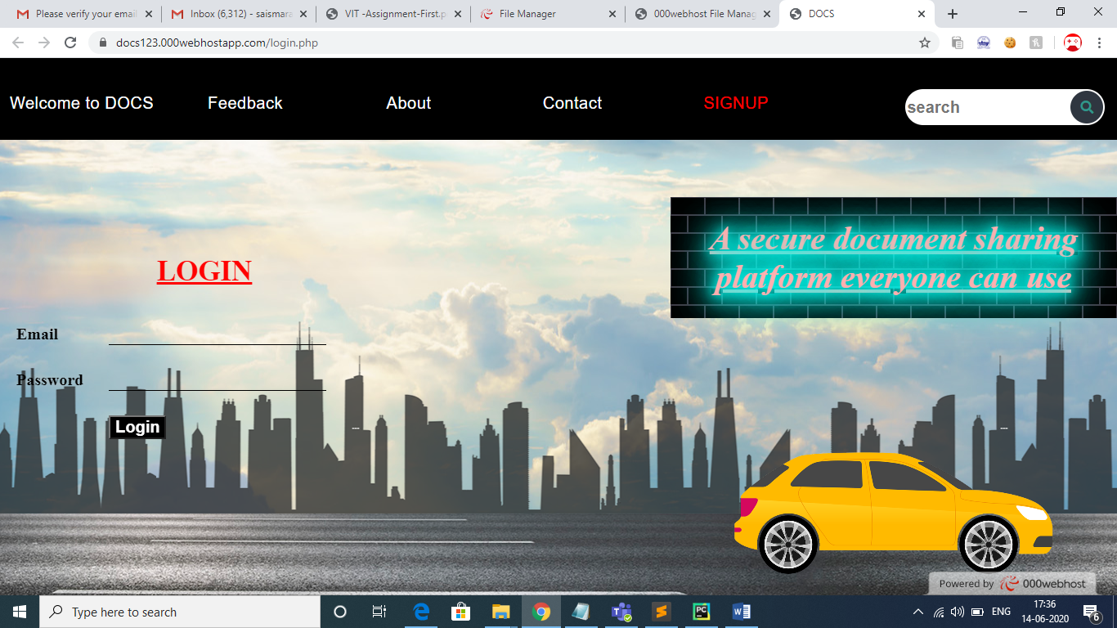

**Error if username and password does not match with database:**

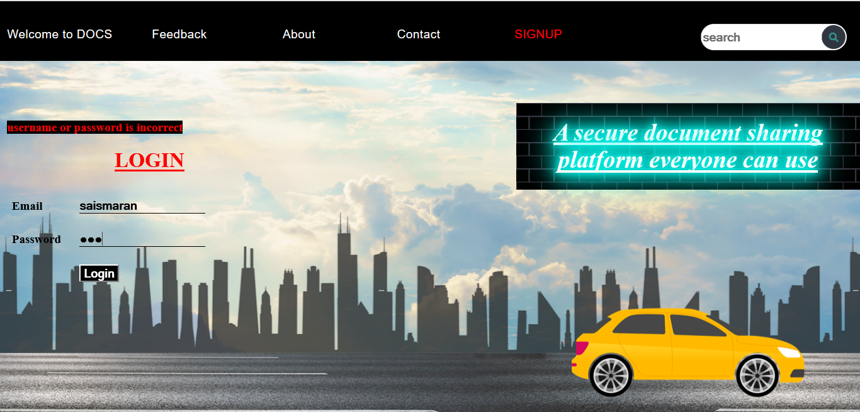

**Home Page:**

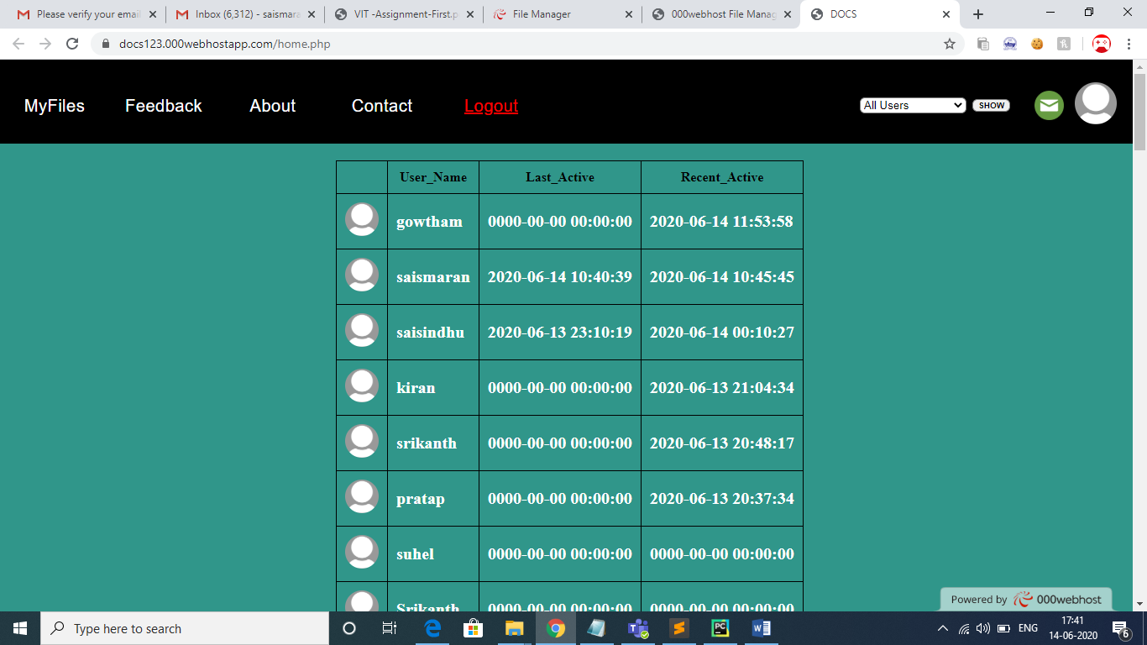

**Shows the User Information When click on avatar:**

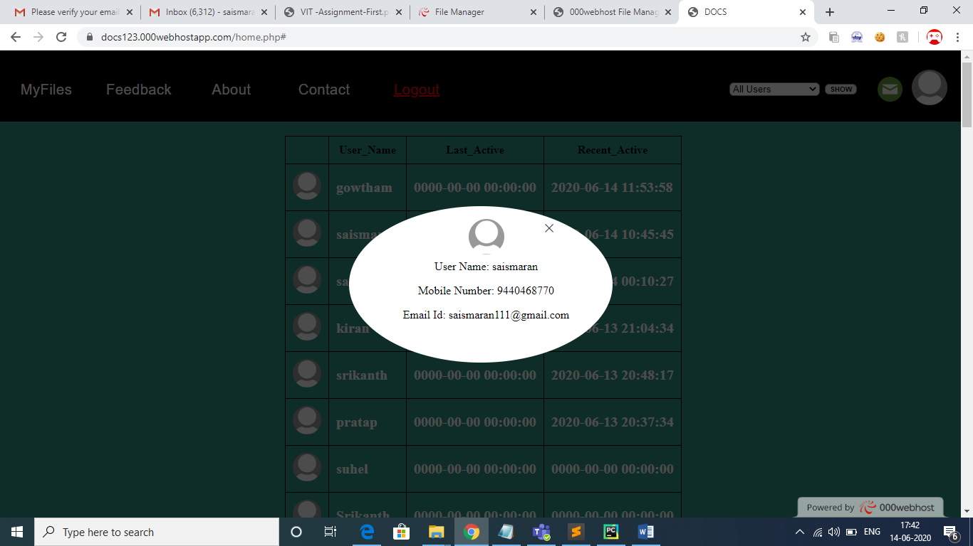

**Display to Share the files when click on share button at top right:**

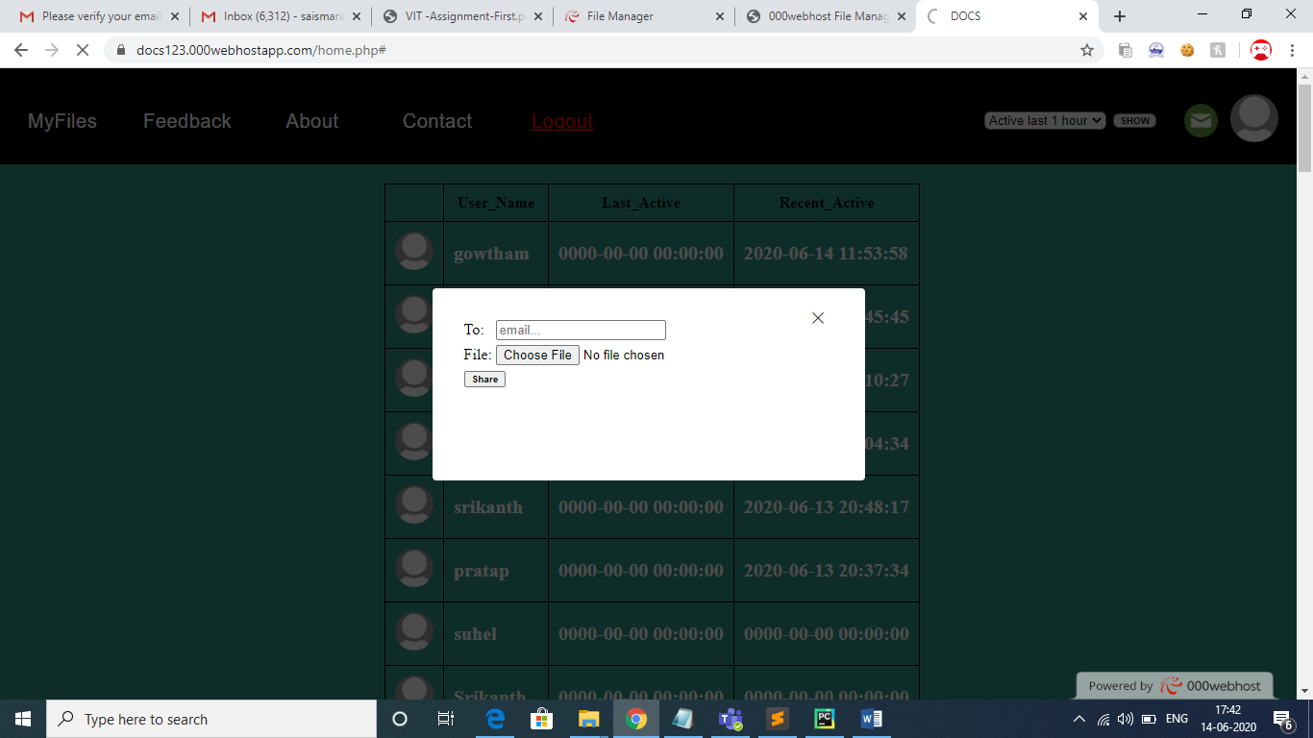

**Displays Active Users:**

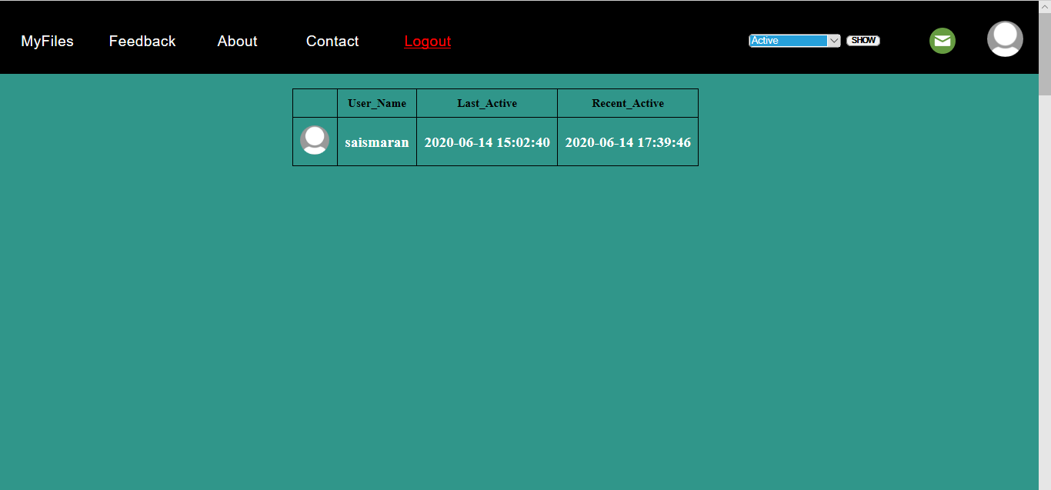

**Displays Active Users before an hour:**

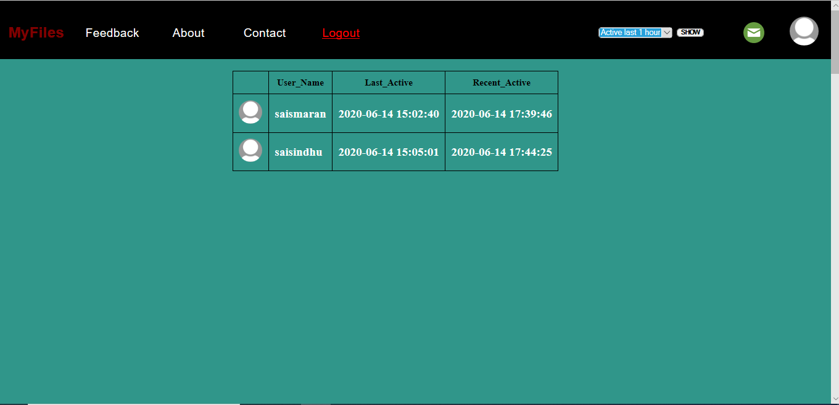

**Success popup for file sharing:**

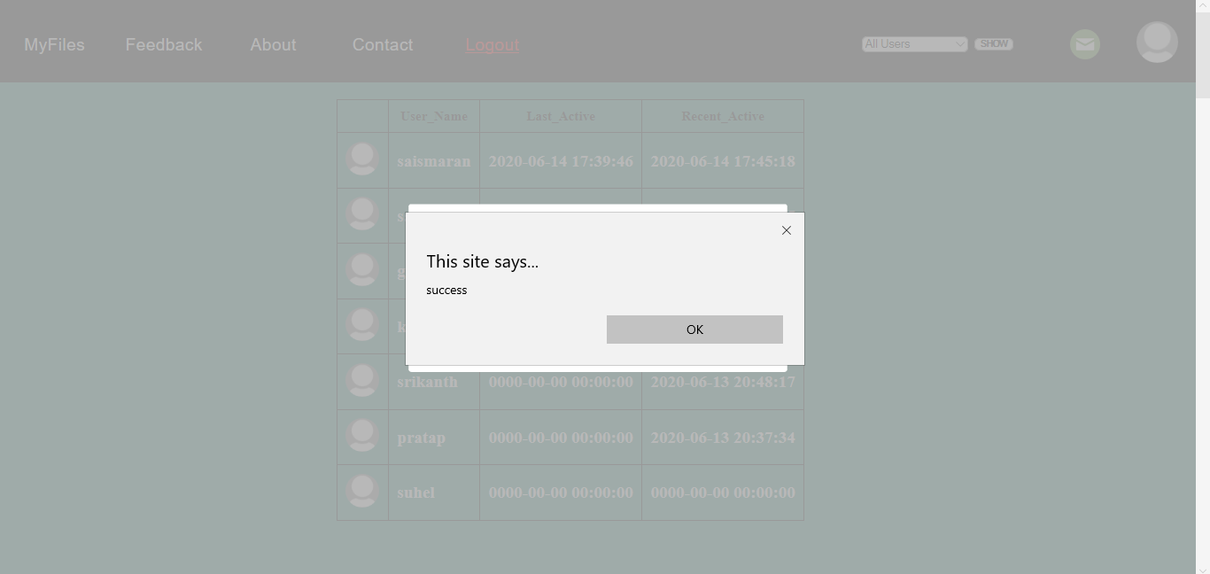

**Verifying file format with png, jpg or txt:**

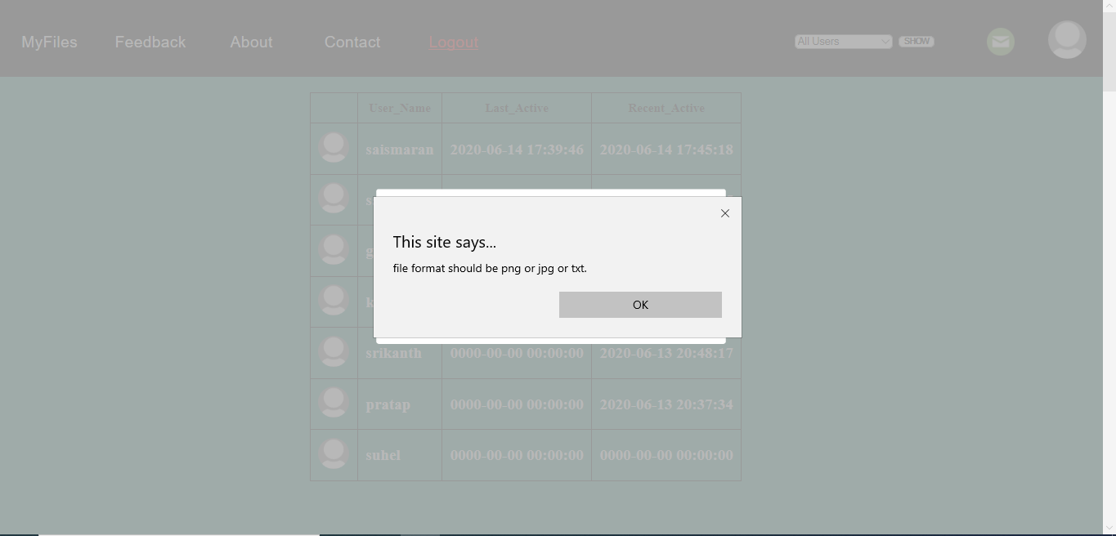

**Displays no files when we click Myfiles if there is none:**

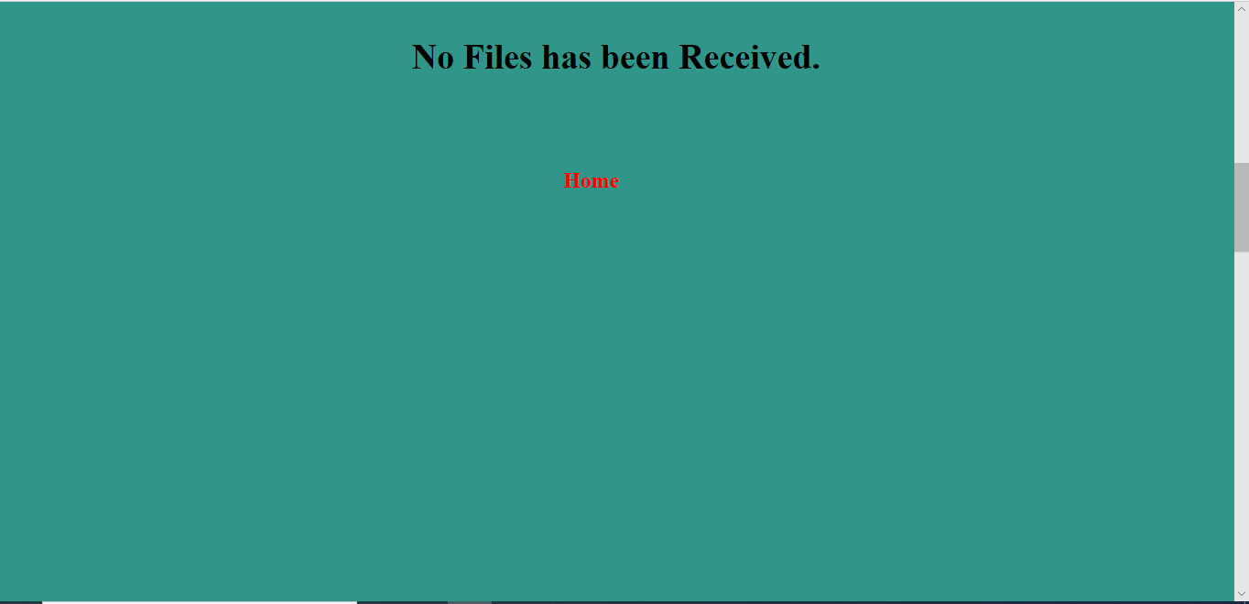

**Displays file and sent from and sent on:**

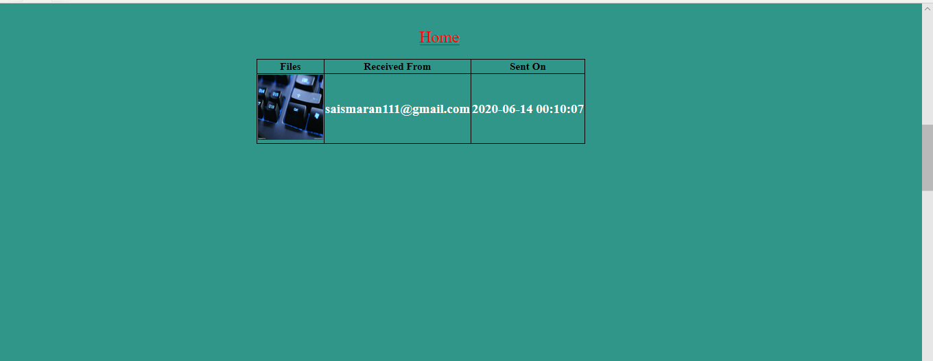

**DATABASE:**

**Users table:**

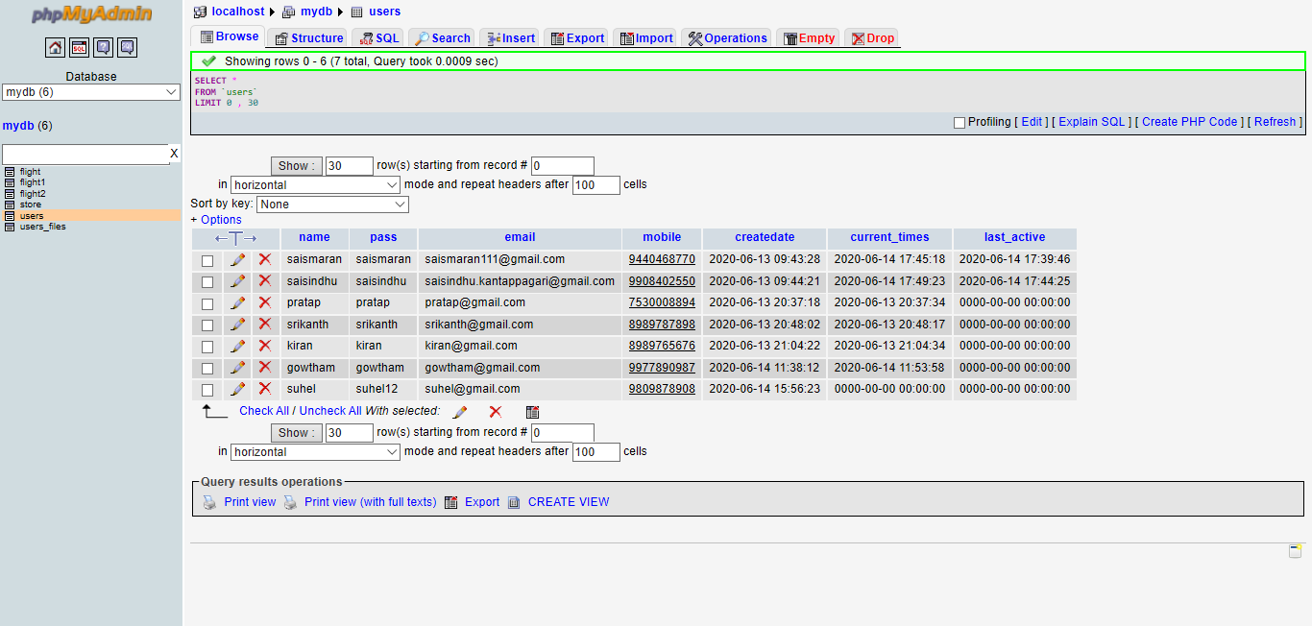

**User_Files table:**

